[https://www.kickstarter.com/projects/heartshapedgames/hero-Genesis/description](https://www.kickstarter.com/projects/heartshapedgames/hero-generations/description)

**Hero Genesis**

Hero Genesis is a quick-playing turn-based strategy game that takes inspiration from rogue-likes, 4X strategy, and independent art games. It has been described as **the** **offspring of** ***Sid Meier’s Civilization***, **Jason Rohrer’s *Passage***, **and *The Legend of Zelda***.

You play a rapidly aging hero that explores a procedurally generated world in search of fame and a mate to settle down with before you die. **After your life ends, you continue on adventuring as your child.** Depending upon your choices, your child will be either more fit to take on the world, or hobbled by your poor decisions.

Hero Genesis is best described as **“The 5-Minute *Civilization*.”** An entire heroic life can be played through in minutes, but chaining together a 2000 year lineage comes from hours of deep strategic play. You move your hero around a procedurally generated grid-based world, and each step they take removes 1 year from their life.

Every turn confronts you with a meaningful choice about how you want to live your life. Do you stay safe and build up your hometown, or explore into the unknown in search of fame and fortune? Do you work to make the world better for your children, or do you selfishly pursue your own dreams?

**Limited Lifespan and Permadeath**: each move your hero makes = 1 year of their life. Each hero has a limited lifespan (from 50-125 years) that puts pressure on you to think carefully about how you spend the years you have left.

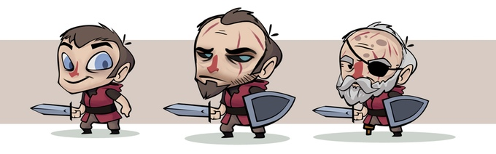Your hero physically ages as you play

**Genesis, Mating, and Having Children:** The world has towns that house mates for you to woo. Successfully finding a mate lets you have a child, and that child becomes the hero you control next in the same world. Choosing the right mate is key, as mates pass on **traits** (special abilities) that make your child more powerful and prepared.

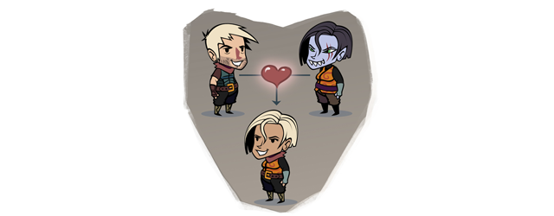

**6 Strategic Paths and Meaningful Choices**: Heroes are judged by how **famous**they become in a single lifespan. Heroes grow and gain fame by completing **quests** and pursuing the following strategic paths:

* ***Strength***: growing in size and strength lets you battle the monsters in your path, and break down barriers to progress.
* ***Love***: work to attract the mate of your dreams, and build an epic legacy of great heroes.
* ***Exploration***: discover what is hidden underneath the clouds, and blaze trails to make traversing the world faster in the future.
* ***Wealth***: collect gold so that you can create buildings in towns or buy items you can pass down to your children.
* ***Fame***: gain fame directly by questing to return ancient artifacts, slaying procedurally generated boss monsters, and competing with other families for the throne.
* ***Building & Technology***: craft amazing towns by building Barracks, Observatories, Museums, and Monuments that offer you helpful resources lasting across Genesis.

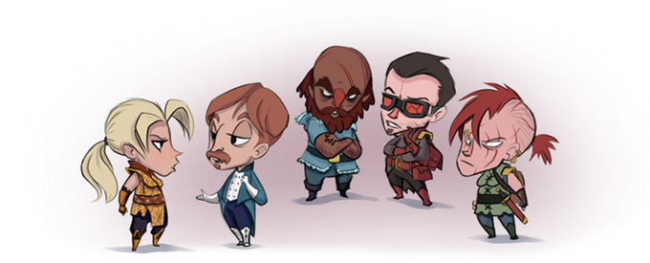

**Building Tech Tree & Family Crafting**: The 4 spaces next to towns allow you to construct special buildings that offer actions and useful resources. Buildings provide long term benefits and influence the **culture**of neighboring towns. Towns morph in response to combinations of buildings nearby, causing the mates in the town to take on unique traits! Examples of discoverable town types include the **Ranch**, **Fortress**, **Ghost Town**, **Port City**, and **Dark Cathedral!**

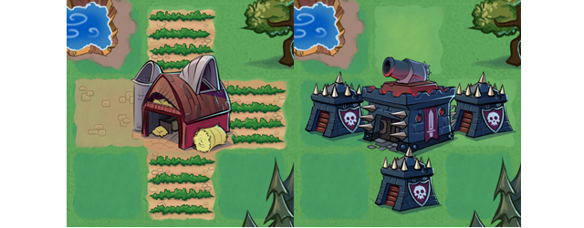

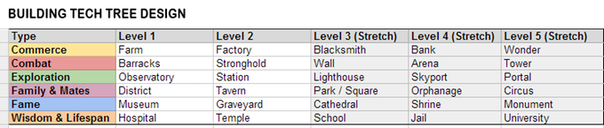Planned Building Tech Tree and Stretch Goals

**Expansive Over world:** Each world of Hero Genesis is a 10x10 procedurally generated grid filled with towns, forests, ancient ruins, monsters, and more. In addition, there is an expansive over world: **a 3x3 grid of connected worlds**. Secret paths at the borders lead to completely different world types. If we meet our stretch goals, we’ll add awesome new world sets that feature totally unique quests, enemies, terrain, and more!

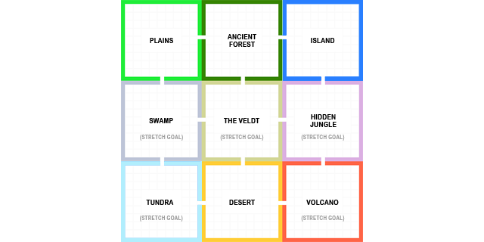

**Prophecies & World Events:** Every 100 years, a major “world event” occurs. Volcanoes erupt; giant creatures emerge hell bent on destroying the world. It can also mean the arrival of helpful special characters, like **wandering** **caravans** and fast traveling **airships**. You’ll be challenged to grow and adapt to an ever-changing world around you.

**Gorgeous Art Style:**The finished game will feature the look and feel I always hoped for, developed by fellow Seattle artist Dominic Sodano. The visuals work to subtly reveal the emotional themes inherent in the game mechanics.

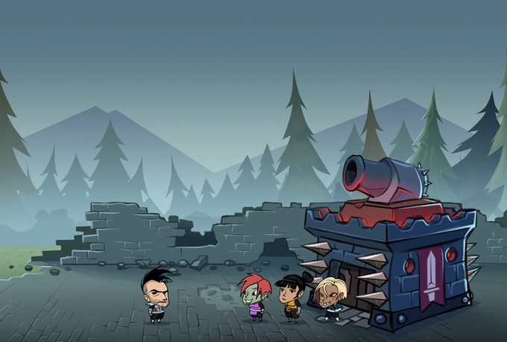

**Simple Yet Deep**: The game system has many elements, but the moment-to-moment gameplay simply involves moving your hero from one grid space to the next like a **rogue-like**. The result is meaningful strategic choices like a 4X Strategy game, but without the heavy micromanagement and calculation.

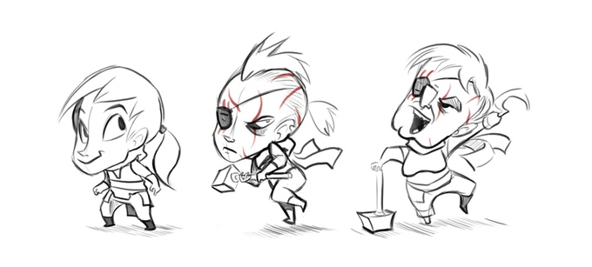Female hero aging along the strength and warrior path.

**Meaning**: The game system was built from the ground up to be an exploration of the themes of death, legacy, family, love, and more. The experience of playing the game I hope will be a surprising and thought-provoking experience, as well as fun. I'll be posting more details on the inspiration and design philosophy behind this in future backer updates.

If we meet our basic funding goal, I will use the funds to convert the prototype into a downloadable, DRM-free version for PC, Mac, and Linux platforms. At a minimum the team and I will implement the following:

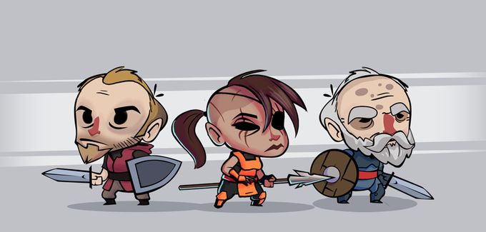

**1. All new art.**We'll create final game art and animation with an all new, polished and fitting style like the mockups and concepts featured on this page.

**2. Support for both male and female heroes.** The prototype supports male heroes and female mates. We'll fix this and add new female hero art.

**3. Over world map.** I'll add support for world tile sets, and procedural generation of the world and connected paths.

**4. New Worlds.** I'll implement a 2nd world type: Desert. In combination with the Grassland and Ancient Forest types, the over world will offer a lot to discover.

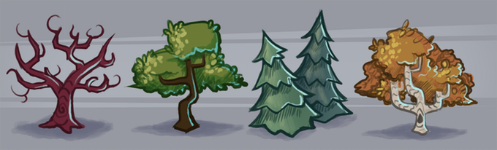

**5. Giant content addition:** I'll add additional character traits, items, quests, enemies, and world events to give all worlds’ long term variety.

**6. Proper mid-term and end game content:** Add the end boss demon and ancient prophecy system to provide goals and tension across many Genesis of heroes.

**7. New UI:** I've learned a lot about what makes a good UI working on Highgrounds, and I'll apply that experience to create a new and streamlined user interface.

**8. Fill out building tech tree with more buildings and building behaviors.**

**9. All new character rig and animations.** We'll update our "paper doll" character system so that characters can be dynamically mated to create new heroes, and have more fluid animations.

**10. Polish:**Fix bugs, improve performance, refactor hacky prototype code, better music and sfx, and generally do all the behind the scenes work necessary to get the game in shape to be deployed as a standalone game that can run across a variety of computers.

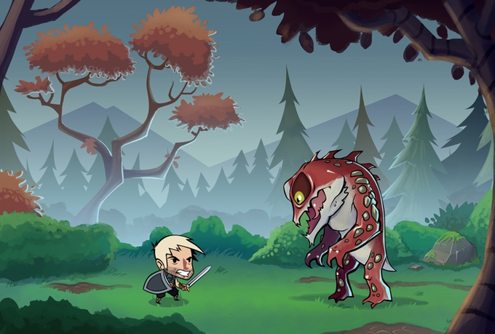

Concept for the battle screen